**Photo Editor App**

**Mini Project**

Submitted in partial fulfillment of the requirement of University of Mumbai

For the Degree of

**(Computer Engineering)**

**By**

**Shweta Madhukar Kaware TU3F1920005**

**Karishma Apparao Bairi TU3F1920014**

**Abhishek Ashok Eitkar TU3F1920013**

**Under the Guidance of**

**Prof. Vishwajeet Gaikwad**



**Department of Computer Engineering**

**TERNA ENGINEERING COLLEGE**

**Plot no.12, Sector-22, Opp. Nerul Railway station,**

**Phase-11, Nerul (w), Navi Mumbai 400706**

**UNIVERSITY OF MUMBAI**



**Terna Engineering College**

**NERUL, NAVI MUMBAI**

CERTIFICATE

*This is to certify that*

**Shweta Madhukar Kaware TU3F1920005**

**Karishma Apparao Bairi TU3F1920014**

**Abhishek Ashok Eitkar TU3F1920013**

*Has satisfactorily completed the requirements of the* ***Mini Project***

*Of subject*

**Mobile Computing**

*As prescribed by the* ***University of Mumbai*** *Under the guidance of*

Prof. Vishwajeet Gaikwad

**HOD**

**Subject Incharge**

**Index**

|  |  |  |
| --- | --- | --- |
| **TABLE OF CONTENTS** | | |
|  |  |  |
| **Caption** |  | **Page No.** |
| Chapter 1 | Introduction | 04 |
| Chapter 2 | Problem Statement | 05 |
| Chapter 3 | Implementation | 06 |
| Chapter 4 | Conclusion | 13 |
|  | Reference | 14 |

**Chapter 1**

**Introduction**

Pico App is the convenient app for image editing. Pico App provides an easy-to-use user interface which allows you to quickly evdit images. Pico App reduces the time and development efforts required to customize your graphical content, saving your time and money. The huge advantage of Pico App is that, unlike other available tools, the actual digital image processing takes place on the client mobile before uploading it to the server. Intuitive and easy-to-use, Pico App lets you edit images faster, while limiting the use of valuable bandwidth. The user can open an image from the mobile and start editing directly. Unlike other available tools all processing takes place on the user's mobile before uploading it to the server. Pico App speeds up the editing process and limits the use of bandwidth. When editing is finished the file can be saved locally. The user can select the file type, set parameters and the file is saved.

**Chapter 2**

**Problem Statement**

Generally problems in photo editing apps is several ads, charges for using features or filters, charges for downloading the image. So the problem we solved here is by keeping it ad free and using features for free.

**Chapter 3**

**Implementation**

MainActivity.java :

package com.mianasad.pico;  
  
import androidx.annotation.Nullable;  
import androidx.appcompat.app.AppCompatActivity;  
import androidx.core.app.ActivityCompat;  
  
import android.Manifest;  
import android.content.Intent;  
import android.content.pm.PackageManager;  
import android.graphics.Bitmap;  
import android.net.Uri;  
import android.os.Bundle;  
import android.provider.MediaStore;  
import android.view.View;  
import android.widget.Toast;  
  
import com.dsphotoeditor.sdk.activity.DsPhotoEditorActivity;  
import com.dsphotoeditor.sdk.utils.DsPhotoEditorConstants;  
import com.google.android.gms.ads.AdRequest;  
import com.google.android.gms.ads.MobileAds;  
import com.google.android.gms.ads.initialization.InitializationStatus;  
import com.google.android.gms.ads.initialization.OnInitializationCompleteListener;  
import com.mianasad.pico.databinding.ActivityMainBinding;  
  
import java.io.ByteArrayOutputStream;  
  
public class MainActivity extends AppCompatActivity {  
  
 ActivityMainBinding binding;  
 int IMAGE_REQUEST_CODE = 45;  
 int CAMERA_REQUEST_CODE = 14;  
 int RESULT_CODE = 200;  
  
 @Override  
 protected void onCreate(Bundle savedInstanceState) {  
 super.onCreate(savedInstanceState);  
 binding = ActivityMainBinding.*inflate*(getLayoutInflater());  
 setContentView(binding.getRoot());  
  
 MobileAds.*initialize*(this, new OnInitializationCompleteListener() {  
 @Override  
 public void onInitializationComplete(InitializationStatus initializationStatus) {  
 }  
 });  
  
 AdRequest adRequest = new AdRequest.Builder().build();  
  
  
 getSupportActionBar().hide();  
  
 binding.editBtn.setOnClickListener(new View.OnClickListener() {  
 @Override  
 public void onClick(View v) {  
 Intent intent = new Intent();  
 intent.setAction(Intent.*ACTION_GET_CONTENT*);  
 intent.setType("image/*");  
 startActivityForResult(intent, IMAGE_REQUEST_CODE);  
 }  
 });  
  
 binding.cameraBtn.setOnClickListener(new View.OnClickListener() {  
 @Override  
 public void onClick(View v) {  
 if(ActivityCompat.*checkSelfPermission*(MainActivity.this,  
 Manifest.permission.*CAMERA*) != PackageManager.*PERMISSION_GRANTED*) {  
 ActivityCompat.*requestPermissions*(MainActivity.this,  
 new String[] {Manifest.permission.*CAMERA*}, 32);  
 } else {  
 Intent cameraIntent = new Intent(MediaStore.*ACTION_IMAGE_CAPTURE*);  
 startActivityForResult(cameraIntent, CAMERA_REQUEST_CODE);  
 }  
 }  
 });  
 }  
  
 @Override  
 protected void onActivityResult(int requestCode, int resultCode, @Nullable Intent data) {  
 super.onActivityResult(requestCode, resultCode, data);  
  
 if(requestCode == IMAGE_REQUEST_CODE) {  
 if(data.getData() != null) {  
 Uri filePath = data.getData();  
 Intent dsPhotoEditorIntent = new Intent(this, DsPhotoEditorActivity.class);  
 dsPhotoEditorIntent.setData(filePath);  
 dsPhotoEditorIntent.putExtra(DsPhotoEditorConstants.*DS_PHOTO_EDITOR_OUTPUT_DIRECTORY*, "Pico");  
 int[] toolsToHide = {DsPhotoEditorActivity.*TOOL_ORIENTATION*, DsPhotoEditorActivity.*TOOL_CROP*};  
 dsPhotoEditorIntent.putExtra(DsPhotoEditorConstants.*DS_PHOTO_EDITOR_TOOLS_TO_HIDE*, toolsToHide);  
 startActivityForResult(dsPhotoEditorIntent, RESULT_CODE);  
 }  
 }  
  
 if(requestCode == RESULT_CODE) {  
 Intent intent = new Intent(MainActivity.this, ResultActivity.class);  
 intent.setData(data.getData());  
 startActivity(intent);  
 }  
  
 if(requestCode == CAMERA_REQUEST_CODE) {  
 Bitmap photo = (Bitmap) data.getExtras().get("data");  
 Uri uri = getImageUri(photo);  
 Intent dsPhotoEditorIntent = new Intent(this, DsPhotoEditorActivity.class);  
 dsPhotoEditorIntent.setData(uri);  
 dsPhotoEditorIntent.putExtra(DsPhotoEditorConstants.*DS_PHOTO_EDITOR_OUTPUT_DIRECTORY*, "Pico");  
 int[] toolsToHide = {DsPhotoEditorActivity.*TOOL_ORIENTATION*, DsPhotoEditorActivity.*TOOL_CROP*};  
 dsPhotoEditorIntent.putExtra(DsPhotoEditorConstants.*DS_PHOTO_EDITOR_TOOLS_TO_HIDE*, toolsToHide);  
 startActivityForResult(dsPhotoEditorIntent, RESULT_CODE);  
 }  
 }  
  
 public Uri getImageUri(Bitmap bitmap) {  
 ByteArrayOutputStream arrayOutputStream = new ByteArrayOutputStream();  
 bitmap.compress(Bitmap.CompressFormat.*JPEG*, 100, arrayOutputStream);  
 String path = MediaStore.Images.Media.*insertImage*(getContentResolver(), bitmap, "Title", null);  
 return Uri.*parse*(path);  
 }  
  
}

Result.java :

package com.mianasad.pico;  
  
import androidx.appcompat.app.AppCompatActivity;  
  
import android.os.Bundle;  
  
import com.google.android.gms.ads.AdListener;  
import com.google.android.gms.ads.AdRequest;  
import com.google.android.gms.ads.InterstitialAd;  
import com.mianasad.pico.databinding.ActivityResultBinding;  
  
public class ResultActivity extends AppCompatActivity {  
  
 ActivityResultBinding binding;  
  
  
  
 @Override  
 protected void onCreate(Bundle savedInstanceState) {  
 super.onCreate(savedInstanceState);  
 binding = ActivityResultBinding.*inflate*(getLayoutInflater());  
 setContentView(binding.getRoot());  
  
 getSupportActionBar().hide();  
  
 binding.image.setImageURI(getIntent().getData());  
  
  
  
  
 }  
}

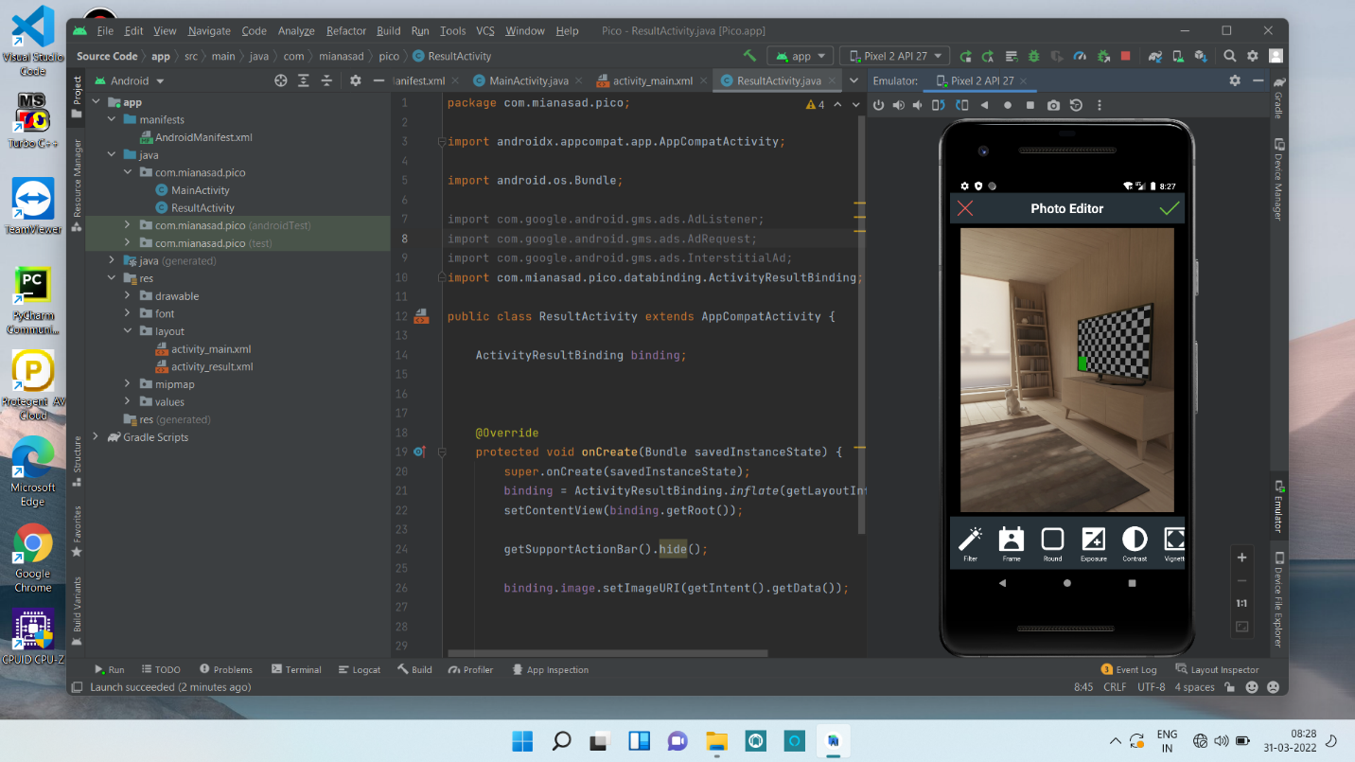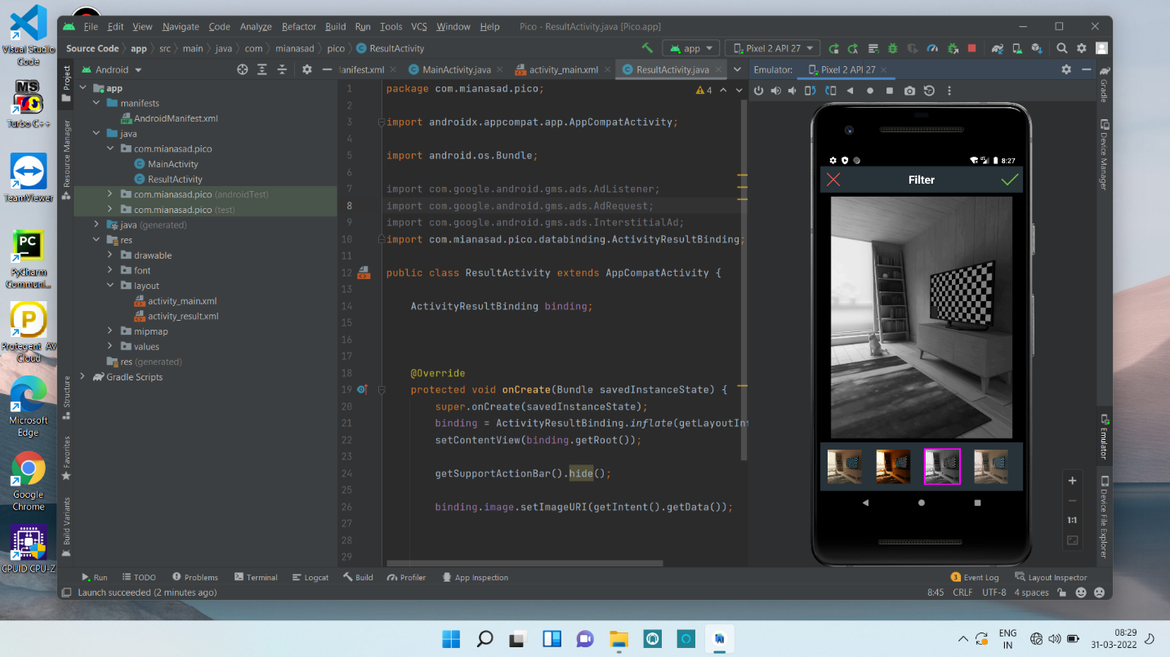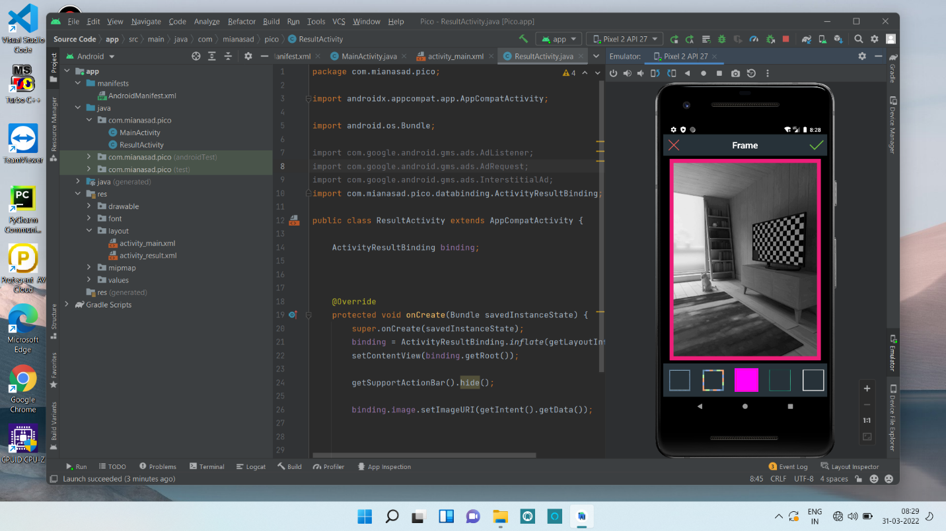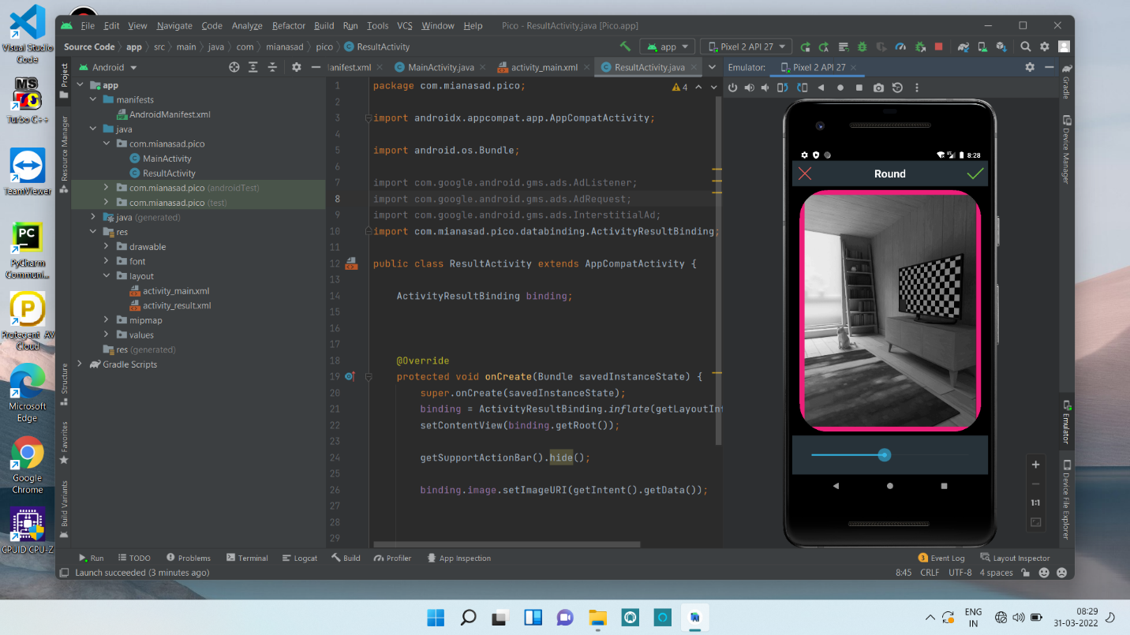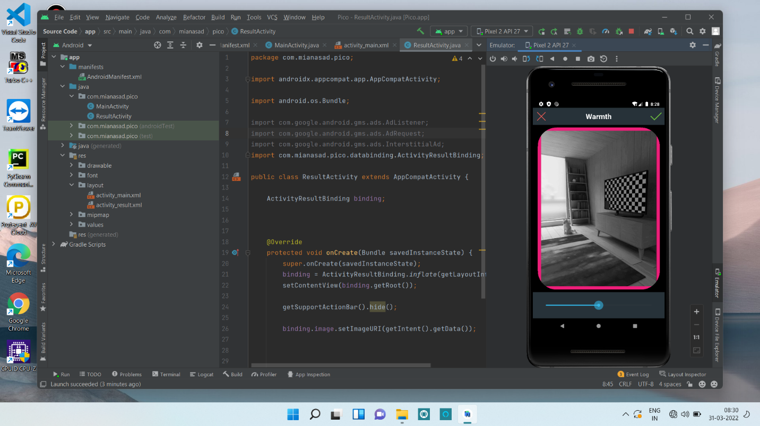

**Chapter 4**

**Conclusion**

Pico app benefits user with free tools. Pico app helps you easily use all the features free of cost. Through Pico app one can edit all types of images . Also one can click picture and edit it in the Pico app itself. Also this app is add free. User can edit images using all the features such as filter, colours, frames, etc.

**References**

* <https://www.kashipara.com/project/java/3475/photoeditor>
* <https://pdfcoffee.com/a-project-report-alfa-image-editor-in-fulfillment-for-the-award-of-the-degree-of-bachelor-of-computer-application-pdf-free.html>
* <http://catalogue.pearsoned.ca/assets/hip/us/hip_us_pearsonhighered/samplechapter/0321168828.pdf>